ANGULAR FINAL TASK

ROAMREADY-A feature-rich Angular-based travel planning website

***LOGIN PAGE***

The Login Page ensures secure access using Guard, restricting other pages until authentication is complete. It uses **Reactive Forms** for validation and authentication, providing a smooth login experience.

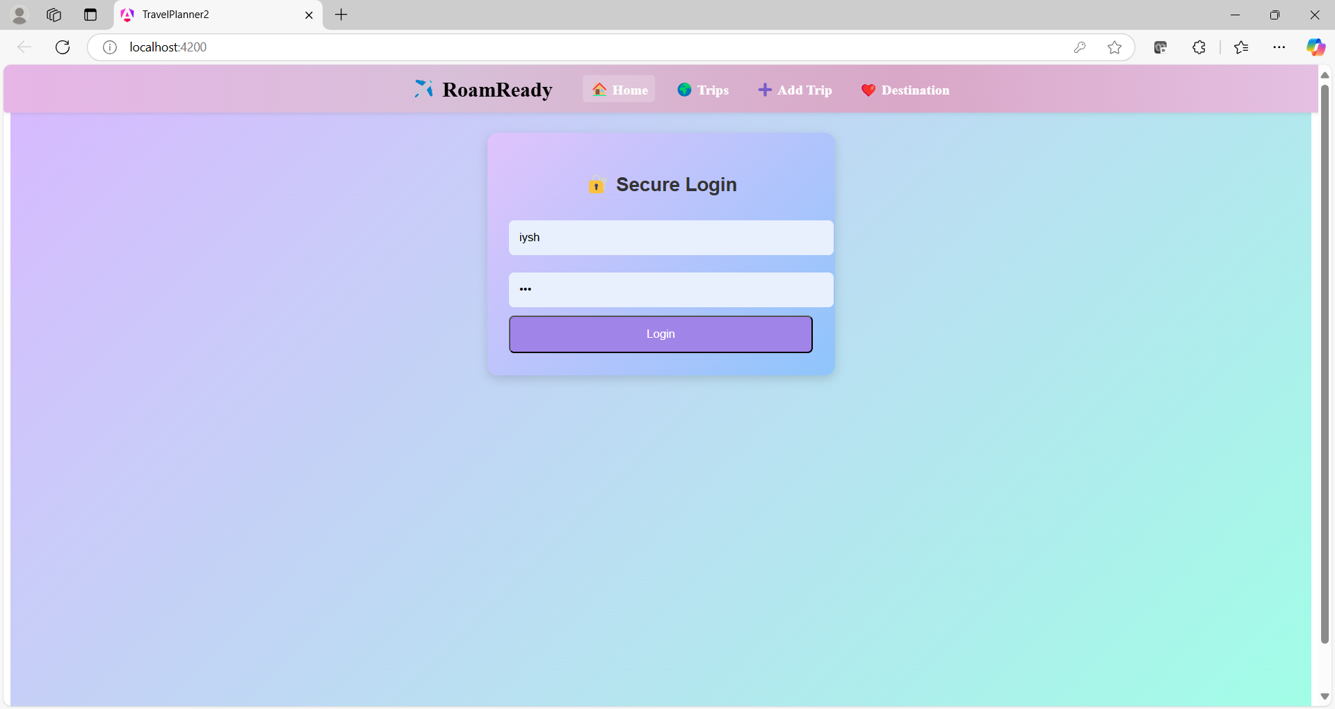

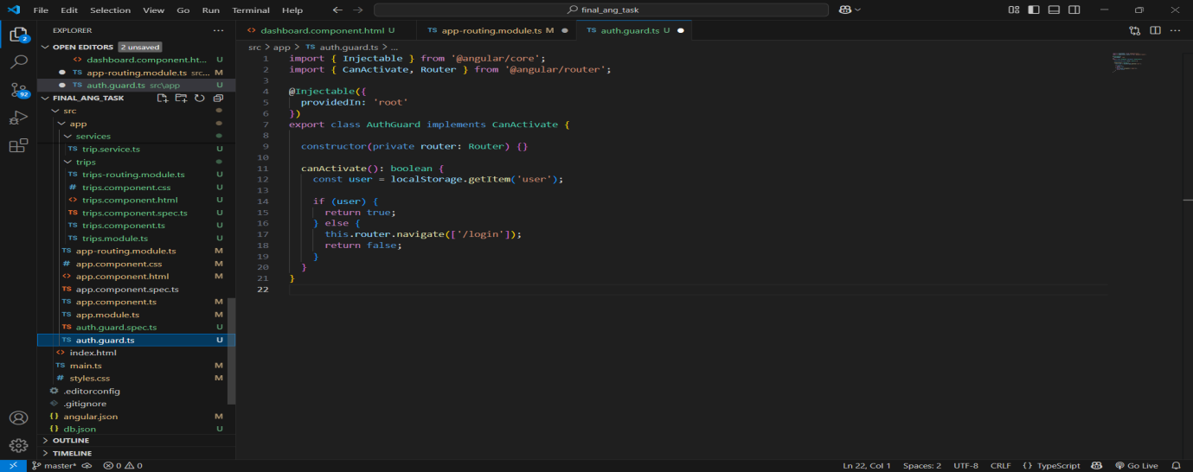

***HOME PAGE***

The Home Page requires user login and features a **navigation menu** for seamless access to different sections. It highlights popular travel destinations with a "Discover More" option to explore additional locations. The "Explore Now" button redirects users to a special deals and discounts page. A visually appealing layout enhances user engagement. It serves as the central hub for navigating the RoamReady travel planner.

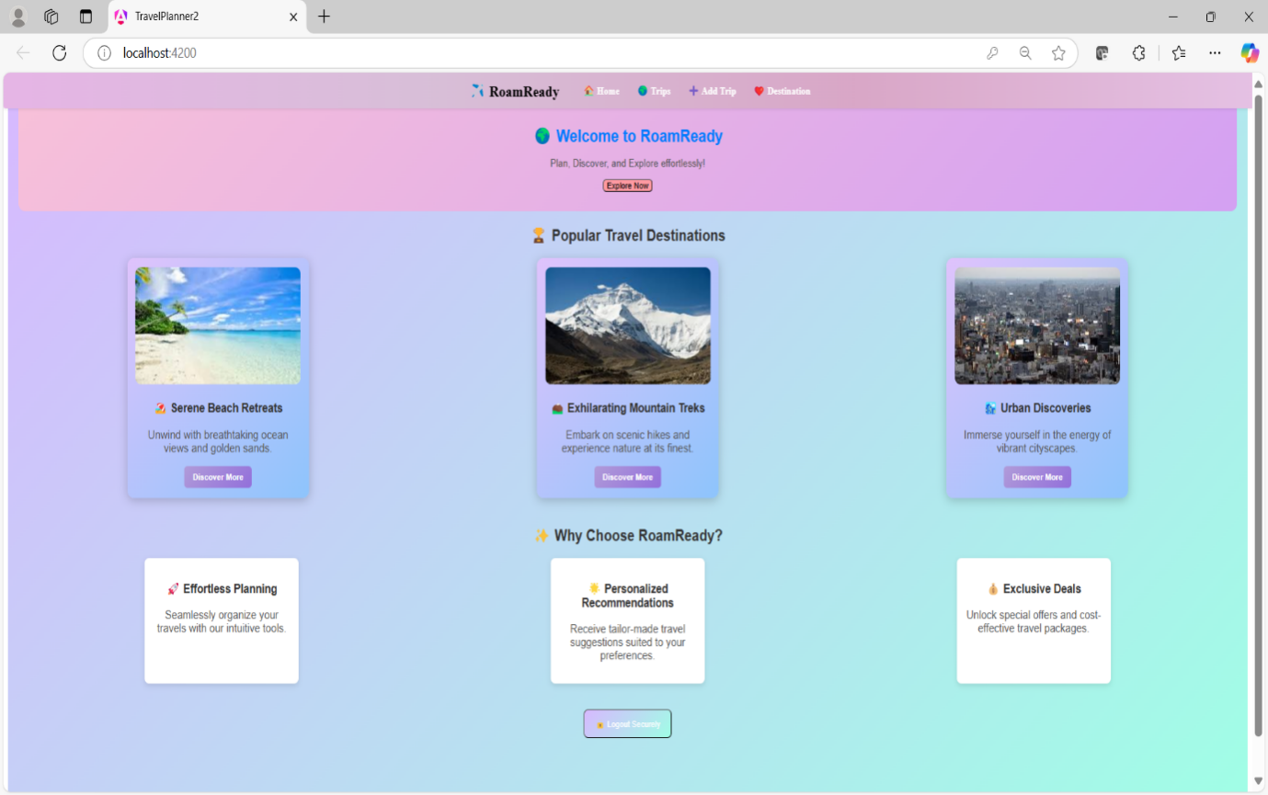

EXPLORE NOW BUTTON---🡪Deals and Discounts Page

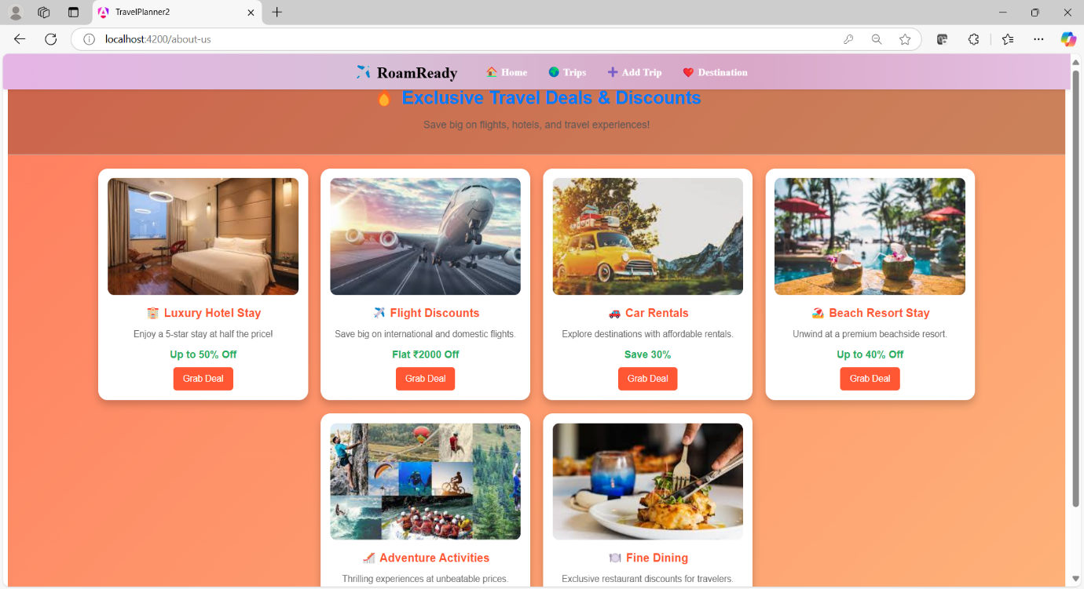

The "Discover More" button on the Home Page redirects users to a new page showcasing additional travel destinations. Routing and navigation ensure a seamless transition between pages. This feature encourages users to explore more travel opportunities

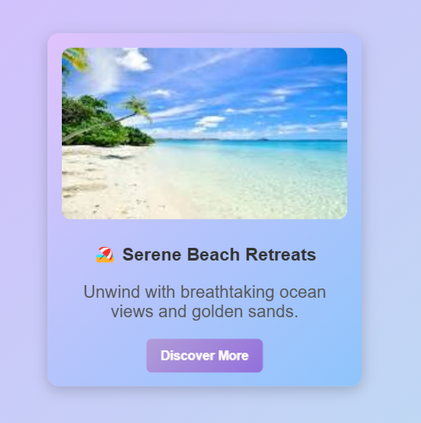

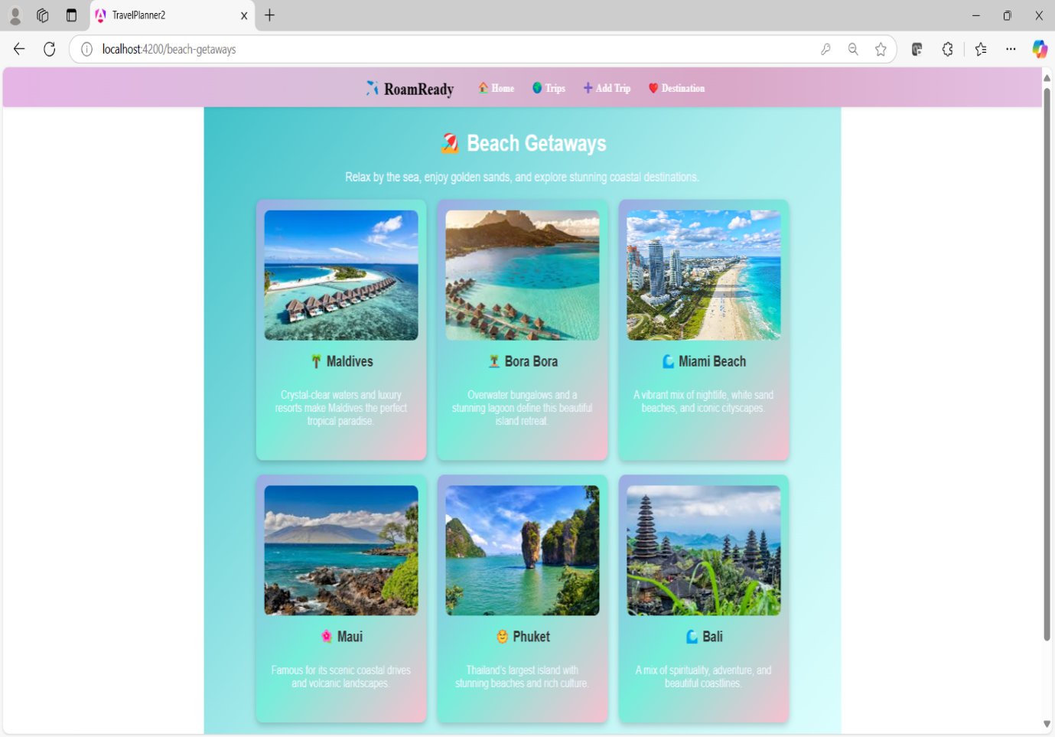

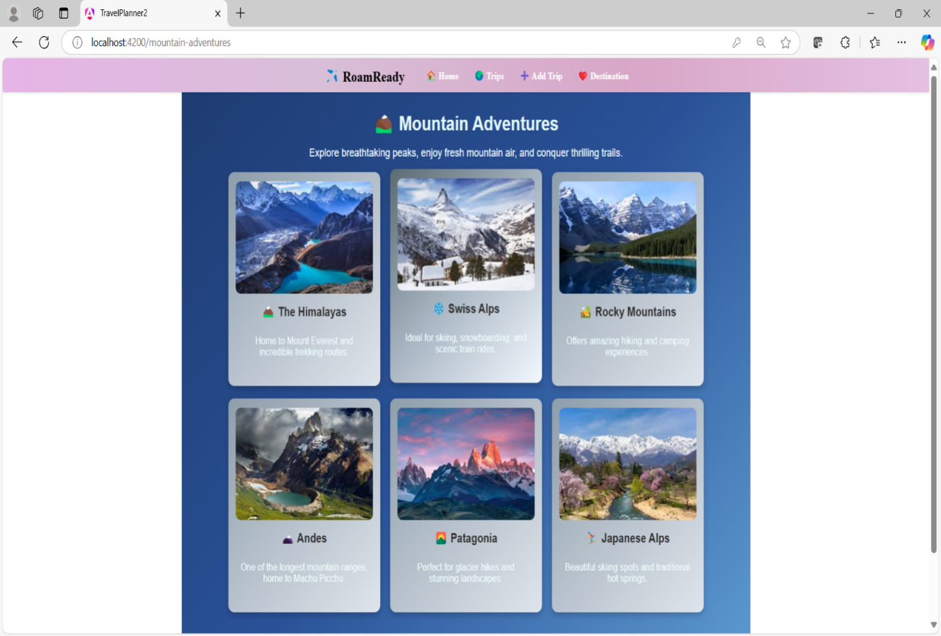

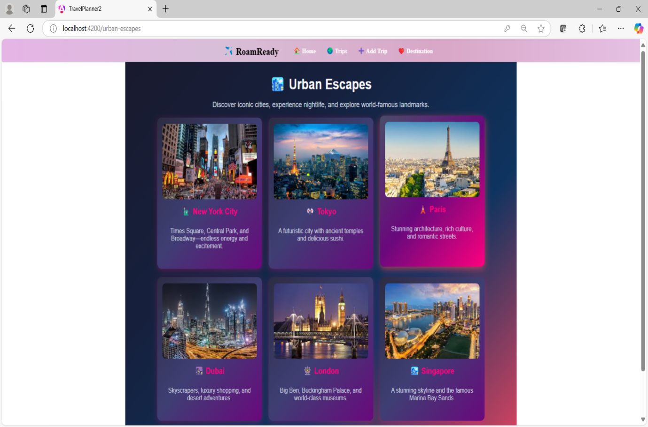

***TRIPS PAGE***

The Trips Page fetches and displays famous tourist destinations in India using **API calls** from db.json. Users can explore various places, each shown as a card with an image, name, and description. The "Add to Wishlist" button stores selected places in Local Storage for future reference. **\*ngFor** is used to dynamically render trip cards. **@Input** and **@Output** enable data sharing between parent and child components, used in trip details and wishlist updates.Services and Observables handle API calls and real-time data updates, used in fetching trips and managing the wishlist.

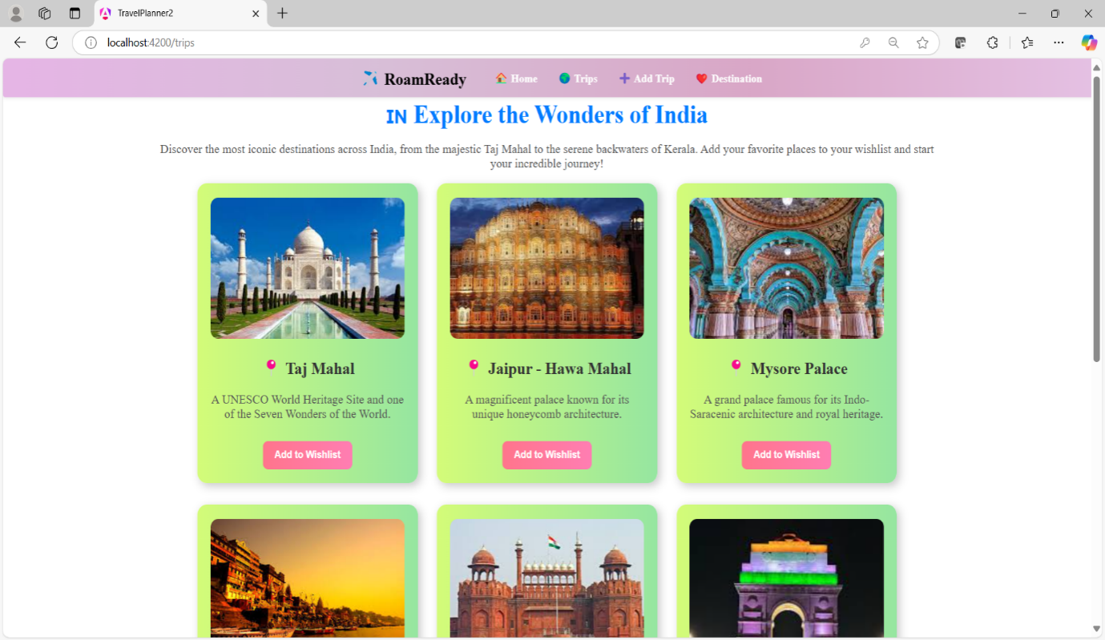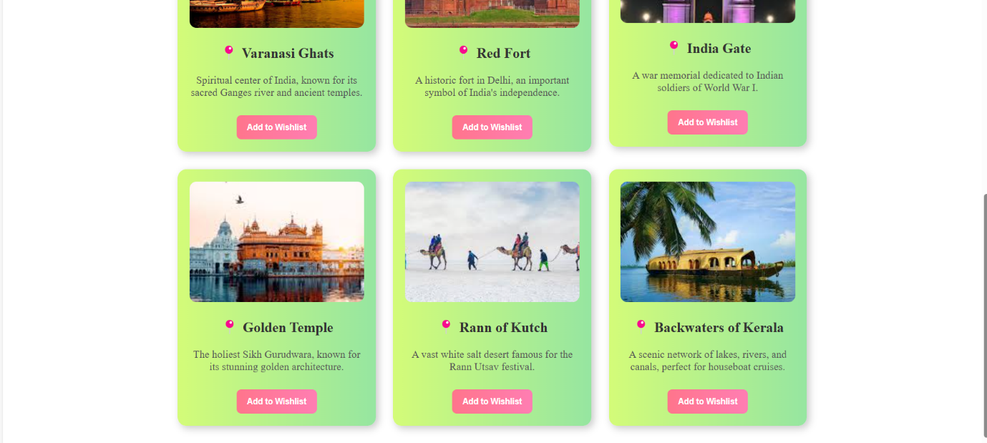

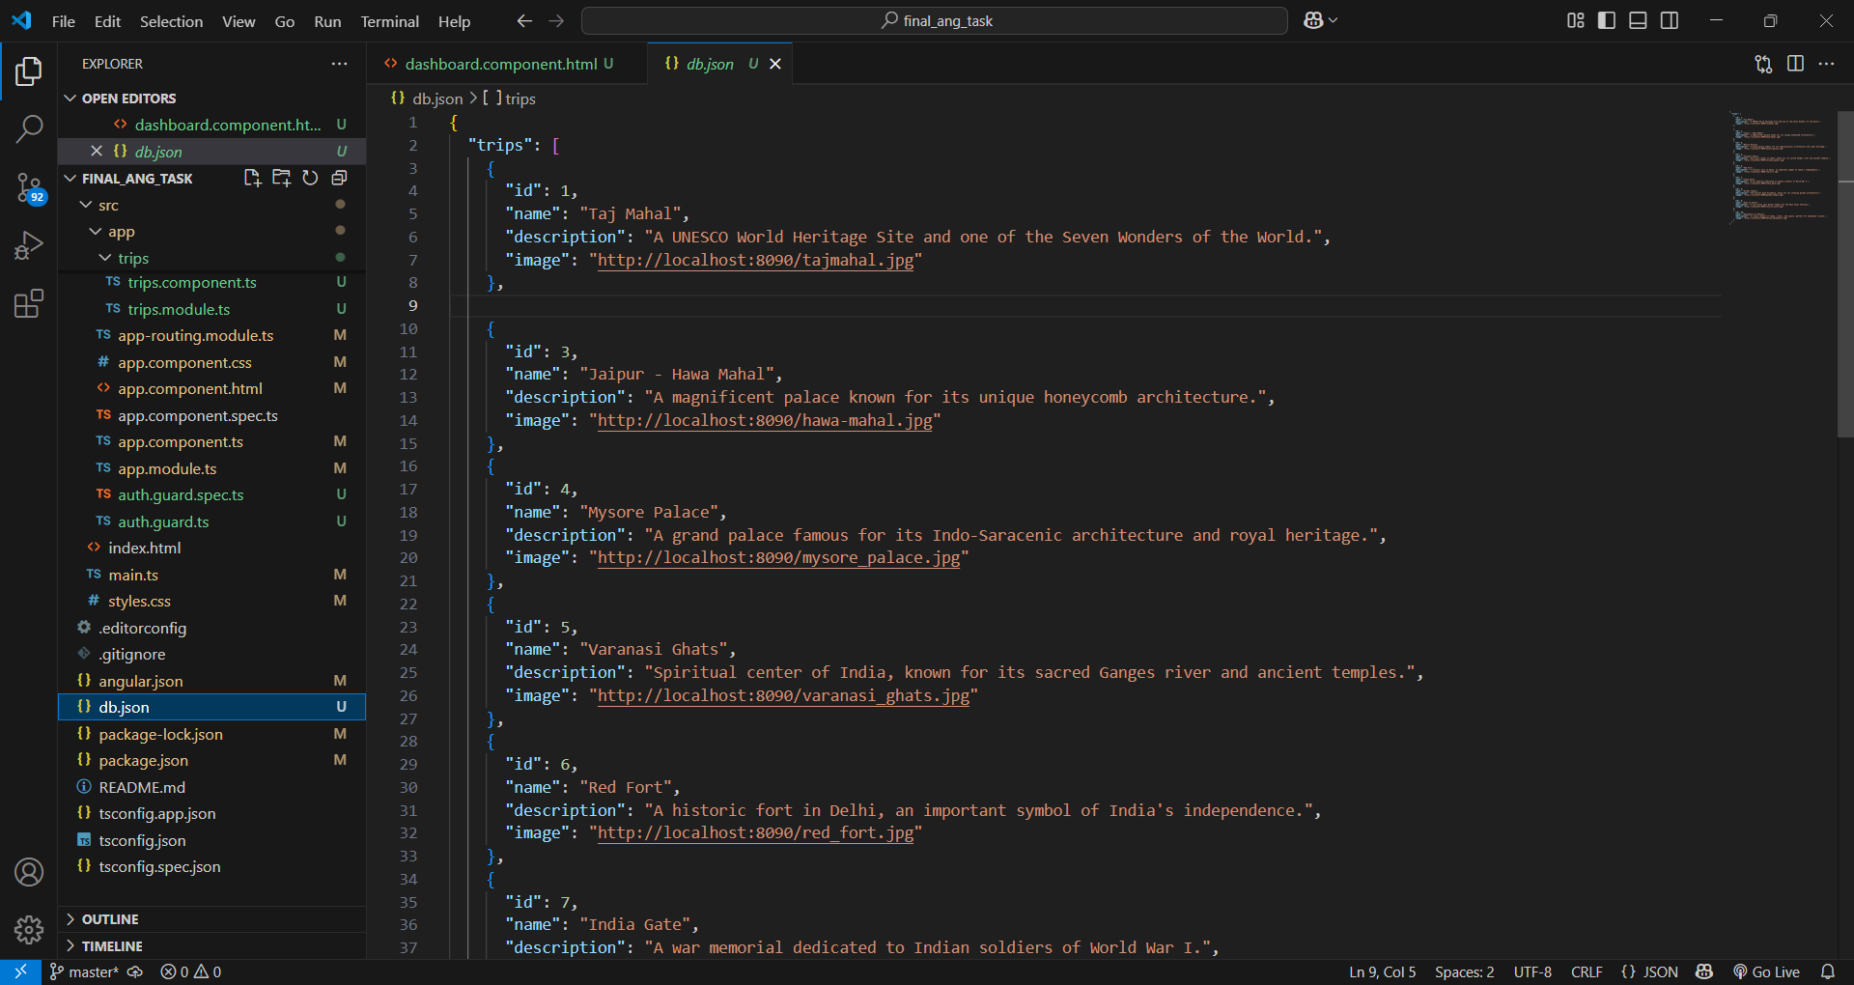

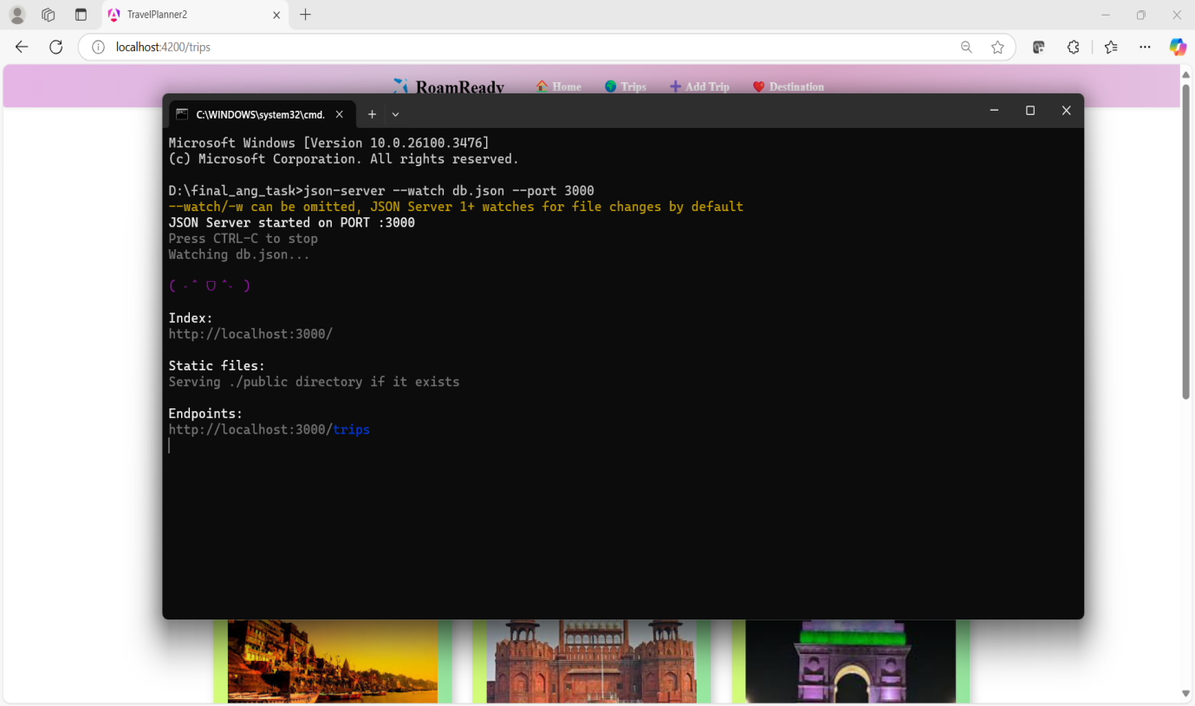

***ADD TRIPS PAGE***

The Add Trip Page allows users to share their travel experiences using a **Template-driven Form**. Users can enter trip details and upload an image from their system, which gets stored **in Local Storage.** The submitted trips, along with images, are displayed immediately on the same page. Form validation ensures proper input handling. This feature enhances user engagement by making trip sharing more interactive.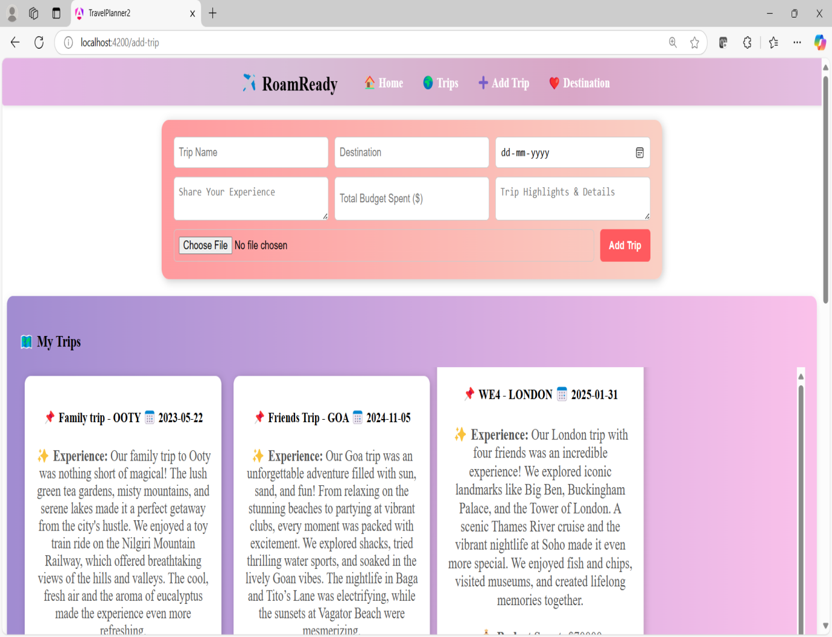

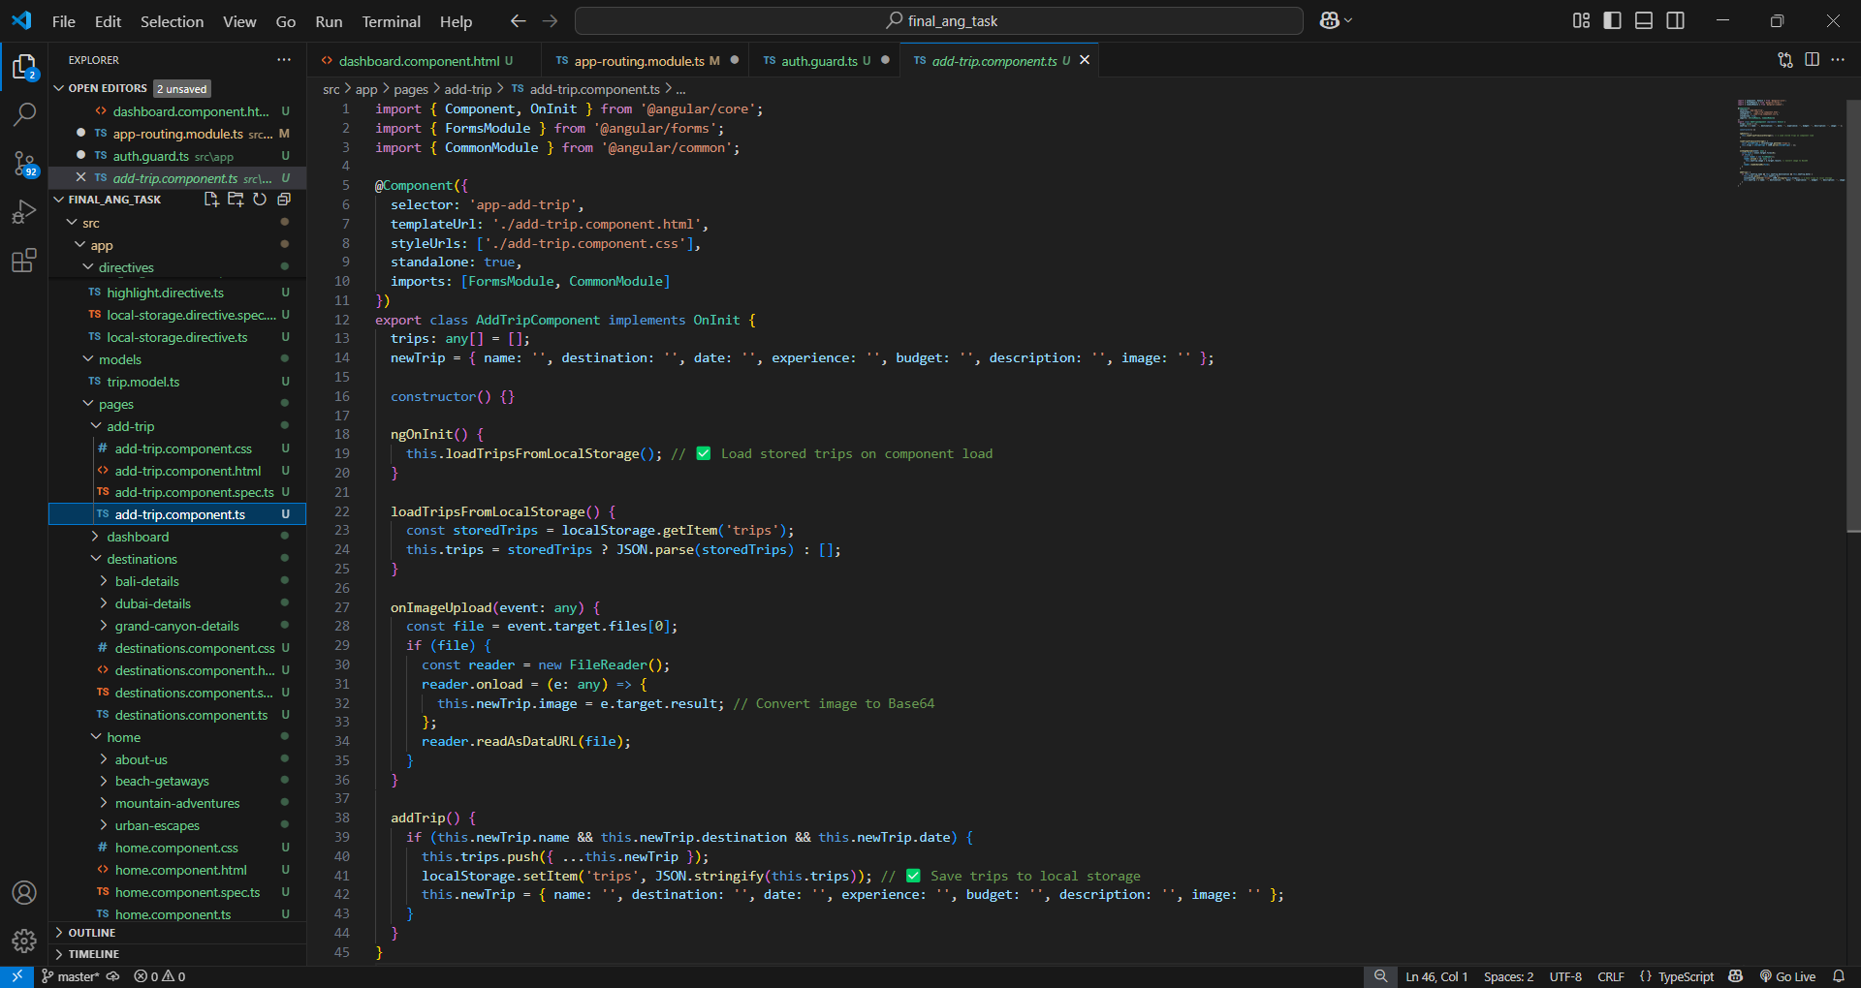

Share your travel experience in the form

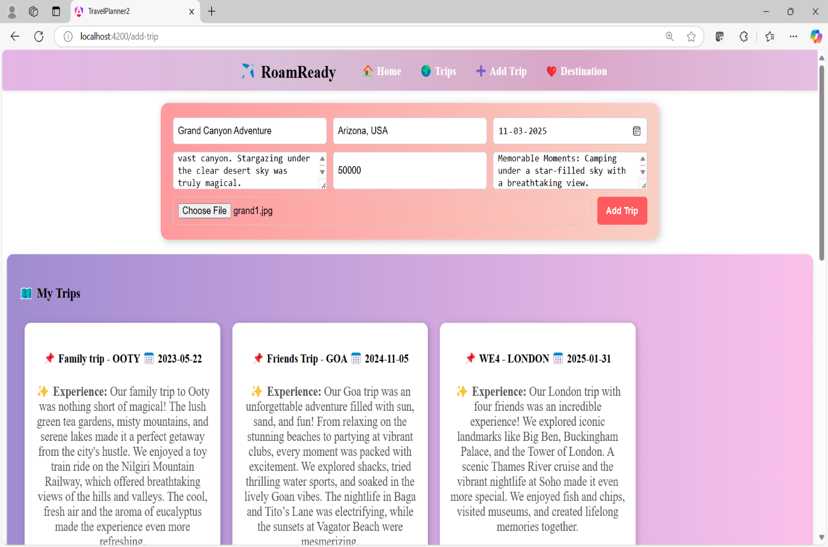

Gets updated in local storage

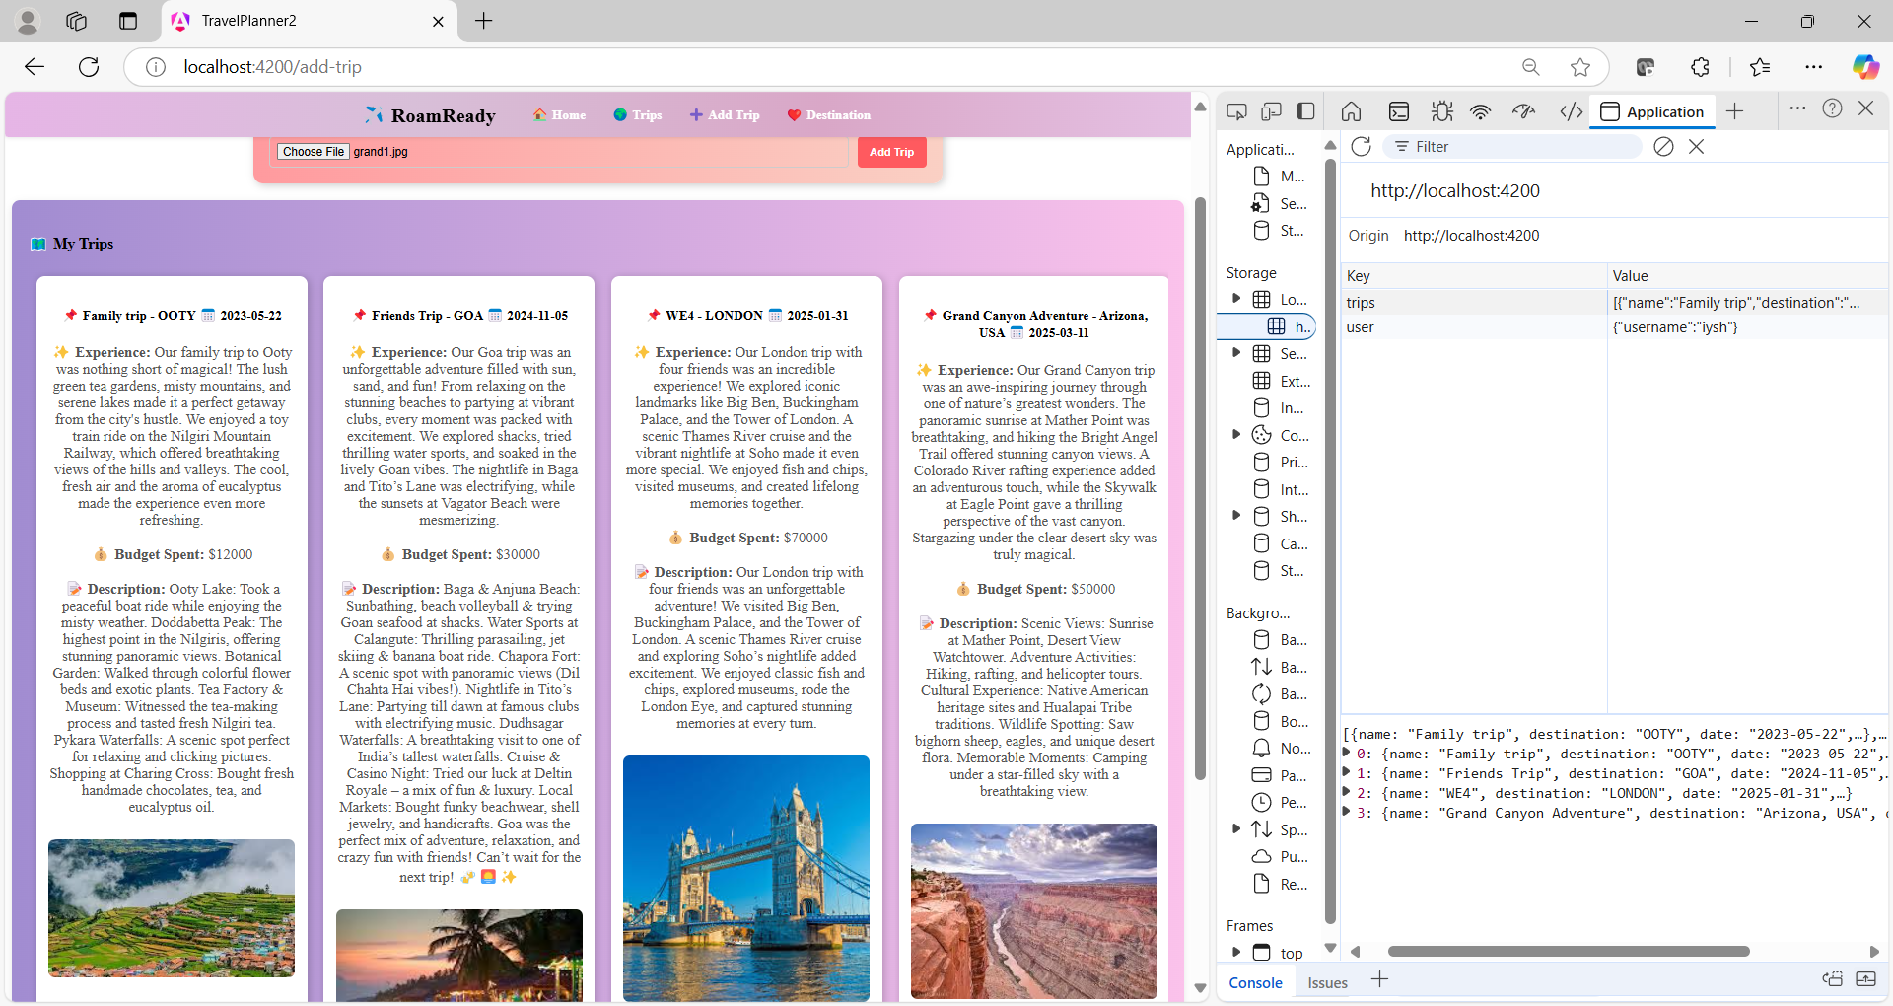

***DESTINATIONS PAGE***

The Destinations Page displays famous travel locations using a card-based layout. It implements **inbuilt pipes** like titlecase, currency, and date for formatting trip details. A **custom pipe** is used to filter destinations dynamically based on user input. The "View More" button provides additional details, including stay options and budget. This page enhances user experience with interactive search and well-structured information. **\*ngIf** is used to **hide content** when no search results match the user input.

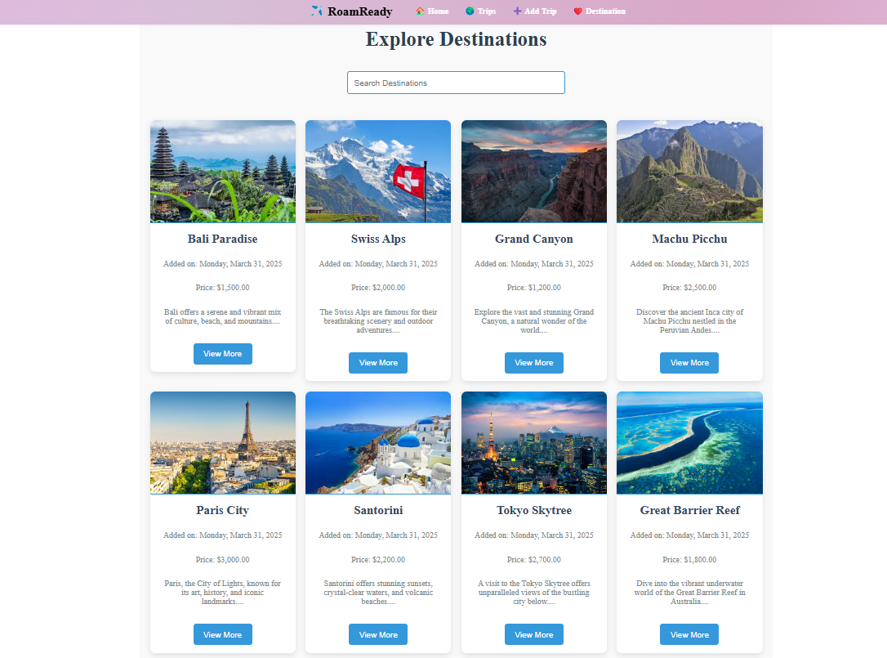

**Inbuilt Pipes:** Angular provides inbuilt pipes like titlecase, date, and currency to format data easily. For example, the Destinations Page uses pipes to display formatted names, dates, and prices dynamically.

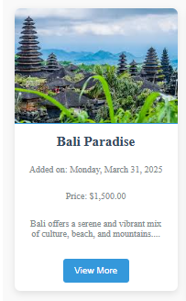

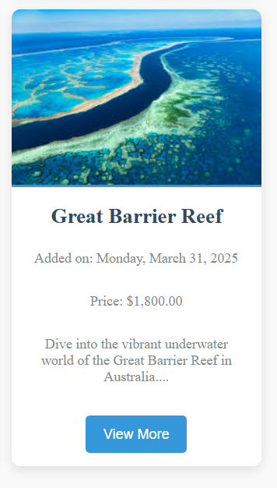

**Custom Pipes:** Custom pipes allow developers to create personalized data transformations. In your app, a custom filtering pipe is used to dynamically search and highlight destinations based on user input.

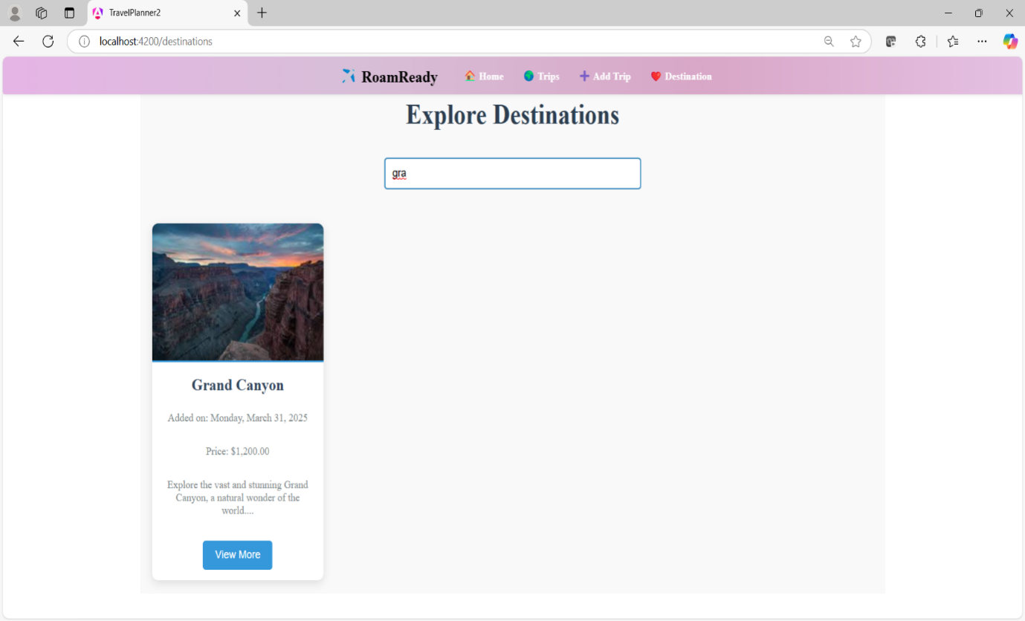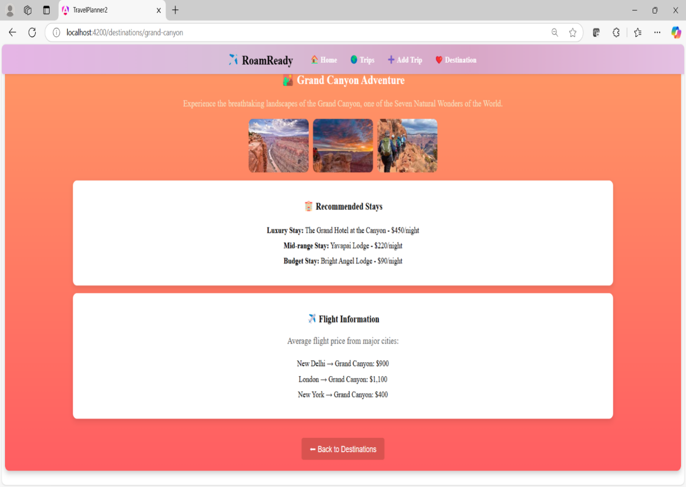

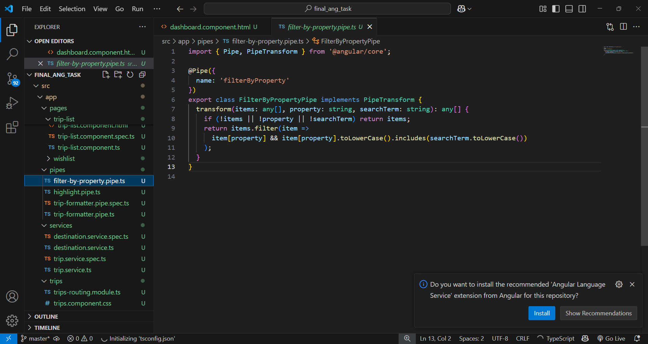

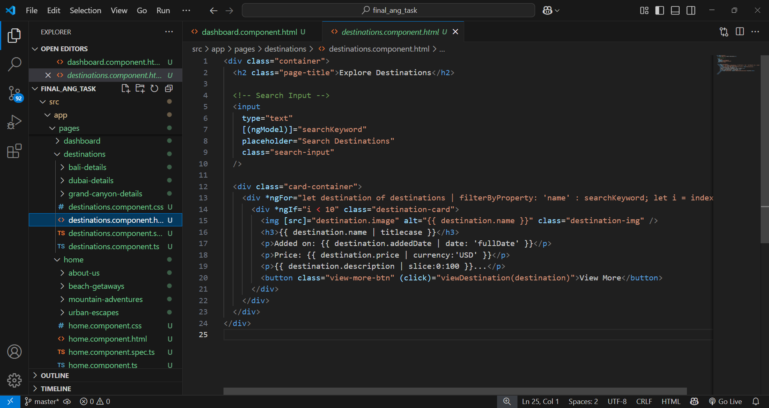

**Modular & Interactive Application Structure:**

* The app is built with **components** like TripsComponent, AddTripComponent, and WishlistComponent, ensuring modularity.
* **Parent-child components** use @Input and @Output for seamless data sharing, such as passing trip details between the **Trips and Wishlist** pages.
* **Directives** like *ngFor and *ngIf dynamically render trip lists and user-added experiences.

**Data Handling, Routing & API Integration:**

* **Routing and Route Parameters** (/trip/:id) enable navigation between trip details and other pages.
* **Local storage** is used to save user trips and wishlist items.
* **AuthGuard** restricts access to protected routes like the Wishlist page until login.
* **Services & Observables** (TripService) manage API calls from db.json, fetching and displaying data dynamically.
* **Form Handling** (Template-driven in AddTripComponent) allows users to submit trip experiences.
* **Pipes** (inbuilt & custom) format and filter data, enhancing the UI in the Destinations and Trips pages.

